Automations using FA.AI CHAT BOT:

1. **BAN Update/Patch Up**  
     
   @faai banupdate "dslorderid,ban" @here

This use case is used to update BAN manually in BRASS DB and sends UNR to BBW.

Chat room: <http://launch.q.att.com/meeting/q_rooms_dj23071551897452040/FAAI+For+BRASS>

**Mannix Noel Arato(12:32:20 AM):** @faai banupdate "FMOB1161314,300793166" @here

**faai(12:32:22 AM):** Thanks, as requested final output will be displayed in meeting room instead of a html page, please wait...

**faai(12:32:25 AM):** Hi Mannix,

Provided UBAN is same as existing one, hence no update needed

1. **Offer ID and Name update**  
     
   @faai offerupdate "dslorderid,offername,offerid" @here

This use case is used to update BANDWIDTH as per user’s request and sends UNR to BBW.

Chat room: <http://launch.q.att.com/meeting/q_rooms_dj23071551897452040/FAAI+For+BRASS>

1. **Single IP Update:**  
   @faai singleipupdate "dslorder,gatewayip" @here

This use case is used to update single IP and sends UNR to BBW.

Chat room: <http://launch.q.att.com/meeting/q_rooms_dj23071551897452040/FAAI+For+BRASS>

1. **Multiple IP Update:**  
     
   @faai multi ip update "dslorder,gatewayip,startip,endip" @here

This use case is used to update multiple IPs and sends UNR to BBW.

Chat room: <http://launch.q.att.com/meeting/q_rooms_dj23071551897452040/FAAI+For+BRASS>

1. **NTT Update**  
   @faai nttupdate "dslorderid,ntt" @here

This use case is used to update HSIA Network type and sends UNR to BBW.

Chat room: <http://launch.q.att.com/meeting/q_rooms_dj23071551897452040/FAAI+For+BRASS>

**Anna Delino(12:46:43 AM):** @faai nttupdate "FMO1174165,FTTN" @here

**faai(12:46:48 AM):** Thanks, as requested final output will be displayed in meeting room instead of a html page, please wait...

**faai(12:46:52 AM):** Hi Anna,

Network type updated successfully for FMO1174165 and notification will be sent to Clarify in next 20 minutes

1. **GLID update**  
   @faai glidupdate "dslorderid, GLID" @here

This use case is used to update GLID. It will send DSL OE to GIOM or UNR to BBW depending upon the scenario.

Chat room: <http://launch.q.att.com/meeting/q_rooms_dj23071551897452040/FAAI+For+BRASS>

1. **STREET1/ADDRESS1 Update**  
   @faai street1update "DSLORDERID,ADDRESS1/STREET1" @here

This use case is used to update service address1/street1. It will send DSL OE to GIOM or UNR to BBW depending upon the scenario.

**Darren Astorias(2:54:06 AM):** @faai street1update "FMOB1183236,1303 W SEPULVEDA BL" @here

**faai(2:54:09 AM):** Thanks, as requested final output will be displayed in meeting room instead of a html page, please wait...

**faai(2:54:13 AM):** Hi Darren,

Street1 updated successfully for Order ID FMOB1183236

From : 1303 SEPULVEDA BLVD

To : 1303 W SEPULVEDA BL

UNR has been sent to Clarify.

Chat room: <http://launch.q.att.com/meeting/q_rooms_dj23071551897452040/FAAI+For+BRASS>

1. **STREET2/ADDRESS2 Update**  
     
   @faai street2update "DSLORDERID,ADDRESS2/STREET2" @here (If you want to remove street2, please use NULL)

This use case is used to update service address2/street2. It will send DSL OE to GIOM or UNR to BBW depending upon the scenario.

**Anthony Alger(12:50:41 AM):** @faai street2update "FMO1176136,STE 130" @here

**faai(12:50:43 AM):** Thanks, as requested final output will be displayed in meeting room instead of a html page, please wait...

**faai(12:50:47 AM):** Hi Anthony,

Street2 updated successfully for Order ID FMO1176136

From :

To : STE 130

UNR has been sent to Clarify.

Chat room: <http://launch.q.att.com/meeting/q_rooms_dj23071551897452040/FAAI+For+BRASS>

Zero touch BOT (Automation by Aisha)

1. **USE CASE: Process Hard Disconnect**

Automation Criteria: HARD DISCONNECT

AISHA will pick, work and close the ticket without any BOA interference for scenario covered. For any other scenario, Aisha will send it to BOA for manual handling

**Scenario covered :** PROB_DETAILS: Please, process HARD DISCONNECT

Sample ticket: 267687079

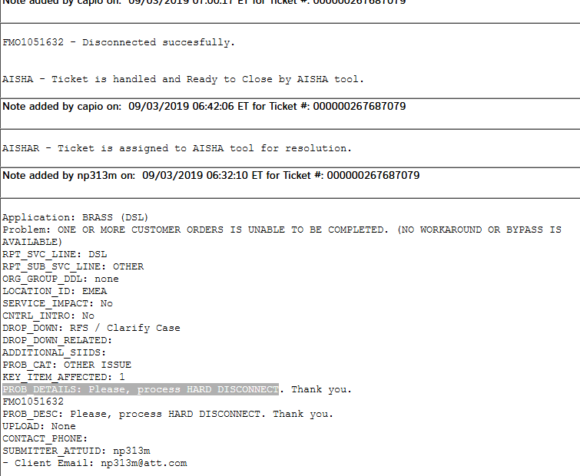

1. **Use case: BAN RETRIGGER**

Automation Criteria : BAN RETRIGGER

AISHA will pick, work and close the ticket without any BOA interference for scenario covered. For any other scenario, Aisha will send it to BOA for manual handling

**Scenario covered –** BAN RETRIGGER

**Sample tickets**: 000000267706257

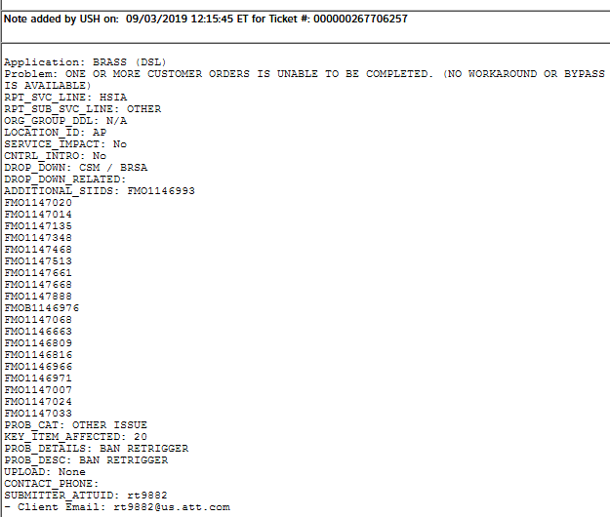

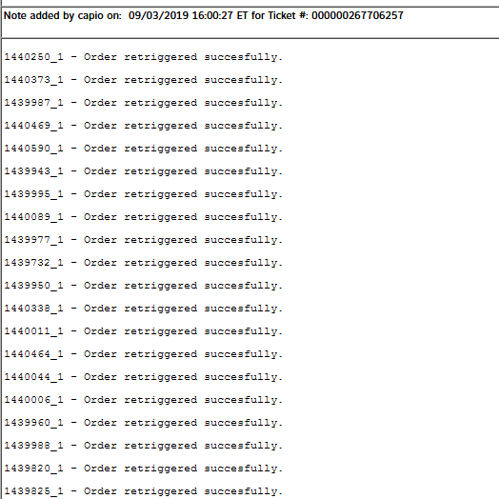

1. **Use Case: Order Cancellation**

Automation criteria : PROB_DETAILS: Please change from cancel pending to cancelled.

AISHA will pick, work and close the ticket without any BOA interference for scenario covered. For any other scenario, Aisha will send it to BOA for manual handling

**Scenario covered –** Order Cancellation

Sample ticket: 000000267783683

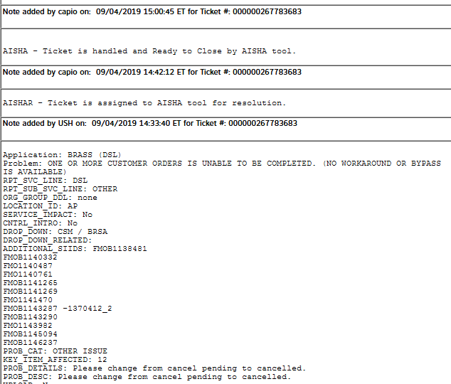

1. **Use Case: Status change to IN-SERVICE**

Automation criteria: PROB_DETAILS: Please, change status to In-Service.

AISHA will pick, work and close the ticket without any BOA interference for scenario covered. For any other scenario, Aisha will send it to BOA for manual handling

**Scenario covered:** Status update to IN-SERVICE

Sample ticket:000000267821391

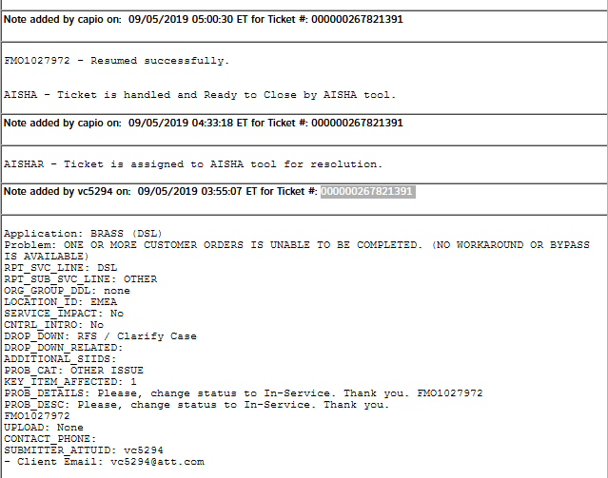

1. **Use Case : NO SMX Profile**

Automation criteria: PROB_DETAILS: NO SMX PROFILE

AISHA will pick, work and close the ticket without any BOA interference for scenario covered. For any other scenario, Aisha will send it to BOA for manual handling

**Scenario covered**: Add data in SMX Queue manually and update IP details

Sample Ticket: 000000268976580

99.189.164.119-99.189.164.125

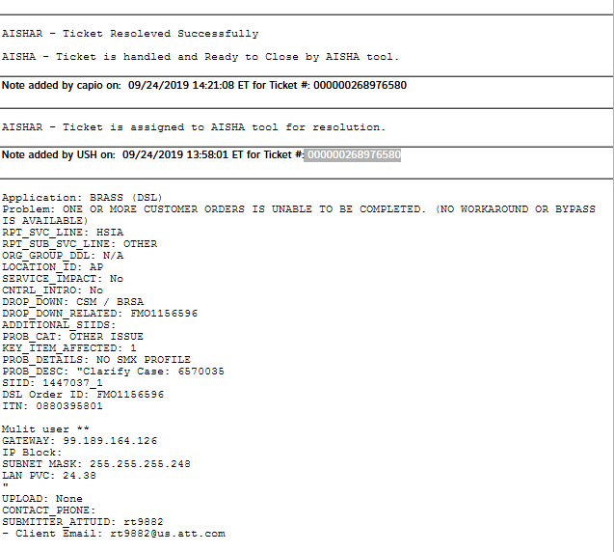

Automation by BSP:

|  |  |  |  |
| --- | --- | --- | --- |
| **S. No** | **Use Case / Bot Name** | **Description** | **Remark** |
| **1** | BRASSCLARIFYINJECT | This Bot is to fix the orders  orders stuck with proc code 100. Tool picks the stuck orders from BRASS DB and will update the missing or wrong data.  **New Issues : Under development** | BOT is triggered every morning at 6:00AM CT from Monday to Friday and BOA can also trigger the BOT manually. |

FMOB1184199 | SDEL0319_007-Brass-ClarifyInject-DSL Service is unavailable. Please process the ticket manually. DSLORDERID is FMOB1184199

FMOB1176205 | Ticket is processed by BOT. DSLORDERID is FMOB1176205 and New Prequal Tracking number is 1600766691